Depatrment of Rheumatology and Rehabilitation

Teaching Hospital Karapitiya

*Common to all patients*

ID

Center

Center ID

Clinic No

Name

Tel

Sex M F

Race S M T M B Other

Religion B M H C Other

Ref by OPD Private Other units or wards Other Hospitals Other

Date of registration

Age at Registration

Address

City

Occupation Student House wife Unskilled workers Skilled workers other

None Clergy Clerical Professionals

**Diagnosis RA, OA, JIA, CTD** (SLE, APS, MCTD, OVERLAP, SCLRODERMA, DEMATO/POLYMOSITIS, SJOGRENS, OTHER -specify), **SpA** (AS, Axial, Preripheral, Mixed Axial and Peripheral, Reactive, Psoriatic, IBD associated, Reiters), **GOUT, Undifferentiated IA,** **VASCULITIS**(TKA, GCA, PAN, KD, AAV, MPA, GPA(WG), EGPA(CSS), Anti-GBM, CV, IgA(HSP), HUV, BD, Other – specify), **Soft Tissue Diseases** (Fibromyalgia, BT, Adhesive Capsulitis, OTHER SJ Ds, TE, GE,DQTS, Ulna Styloid, PF, Achilles’ Tendinitis, Metatarsalgia), **Regional Pain Syndromes** (Back Ach, Neck Pain,Other - specify), **OTHER**-specify

Other

History of DRR

Staff

Regional Pain Syndromes

Undifferentiated IA

Gout

JIA

Soft Tissue Rheumatic

Conditions

Vasculitis

Osteoarthritis

Spondyloarthritis

Photos

Connective Tissue Diseases

Rheumatoid Arthritis

New Patient

Specific diseases for additional details for RA, SLE and SpA

**Rheumatoid Arthritis**

ID

Center

Center ID

Clinic No

Name

Tel

Sex M F

Race S M T M B Other

Religion B M H C Other

Ref by OPD Private Other units or wards Other Hospitals Other

Date of registration

Age at Registration

Address

City

Occupation Student House wife Unskilled workers Skilled workers other

None Clergy Clerical Professionals

Involved joints *finally should be in a table but initially by clicking on a pictorial joint map*

2010 ACR/EULAR Criteria

RF titer *value goes to criteria table*

ESR or CRP *one of the* *value goes to criteria table*

Anti CCP *value goes to criteria table*

Rheumatoid nodules yes no

Complications/extra articular Liver Lung Renal Vasculitis Haematological other

Complications articular Hip OA Knee OA Wrist Elbow A/A sub lux other

Co-morbidities IHD HT DM BA Other

Biological agents used Rituximab Infliximab Tocilizumab Etanercept Golimumab Other

2010 ACR/EULAR CRITERIA

<https://www.rheumakit.com/en/calculators/acr_eular2010>

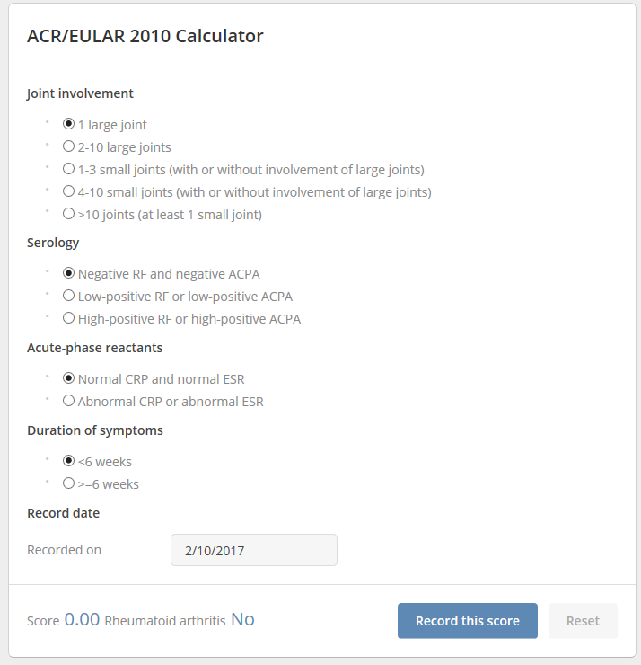

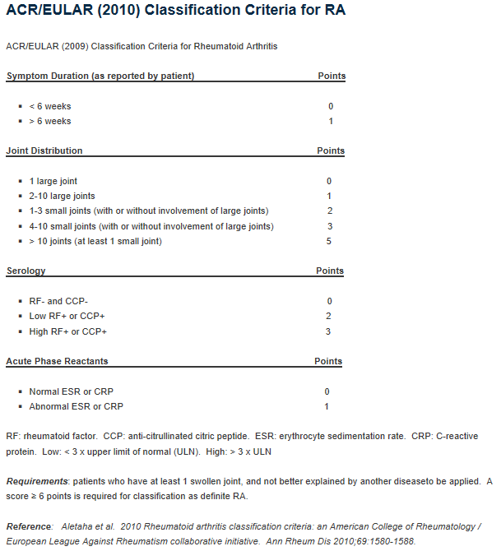

INVOLVED JOINTS

*finally should be in a table but initially by clicking on a pictorial joint map, if possible,* would be great. This is an example which is used to assess the disease activity.

<https://www.rheumakit.com/en/calculators/das28>

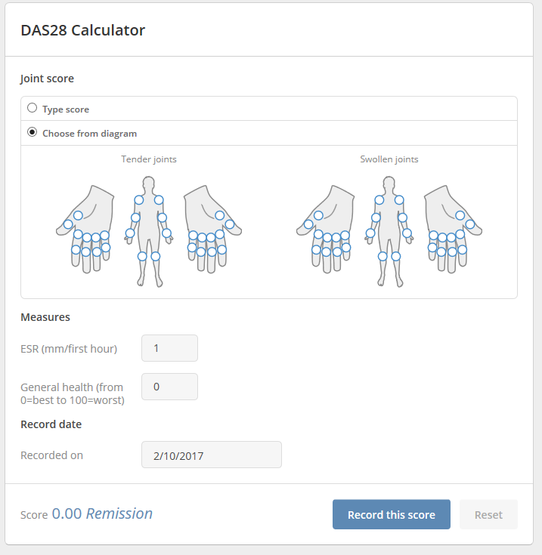

|  |  |  |  |  |
| --- | --- | --- | --- | --- |
|  | Swollen Joints | | Tender joints | |
| L | R | L | R |
| SJ |  |  |  |  |
| EJ |  |  |  |  |
| WJ |  |  |  |  |
| MCP1 |  |  |  |  |
| MCP 2 |  |  |  |  |
| MCP 3 |  |  |  |  |
| MCP 4 |  |  |  |  |
| MCP 5 |  |  |  |  |
| 1ST IP |  |  |  |  |
| PIP 2 |  |  |  |  |
| PIP 3 |  |  |  |  |
| PIP 4 |  |  |  |  |
| PIP 5 |  |  |  |  |
| KJ |  |  |  |  |
| AJ |  |  |  |  |
| MTP |  |  |  |  |